

Bio-Informatics
( Course Code: BIO310 )

Name : Muhammad Abdullah
Roll No # FA24-BSE-042
Intructor Name : Afraz Ahmed

Lab _ Final

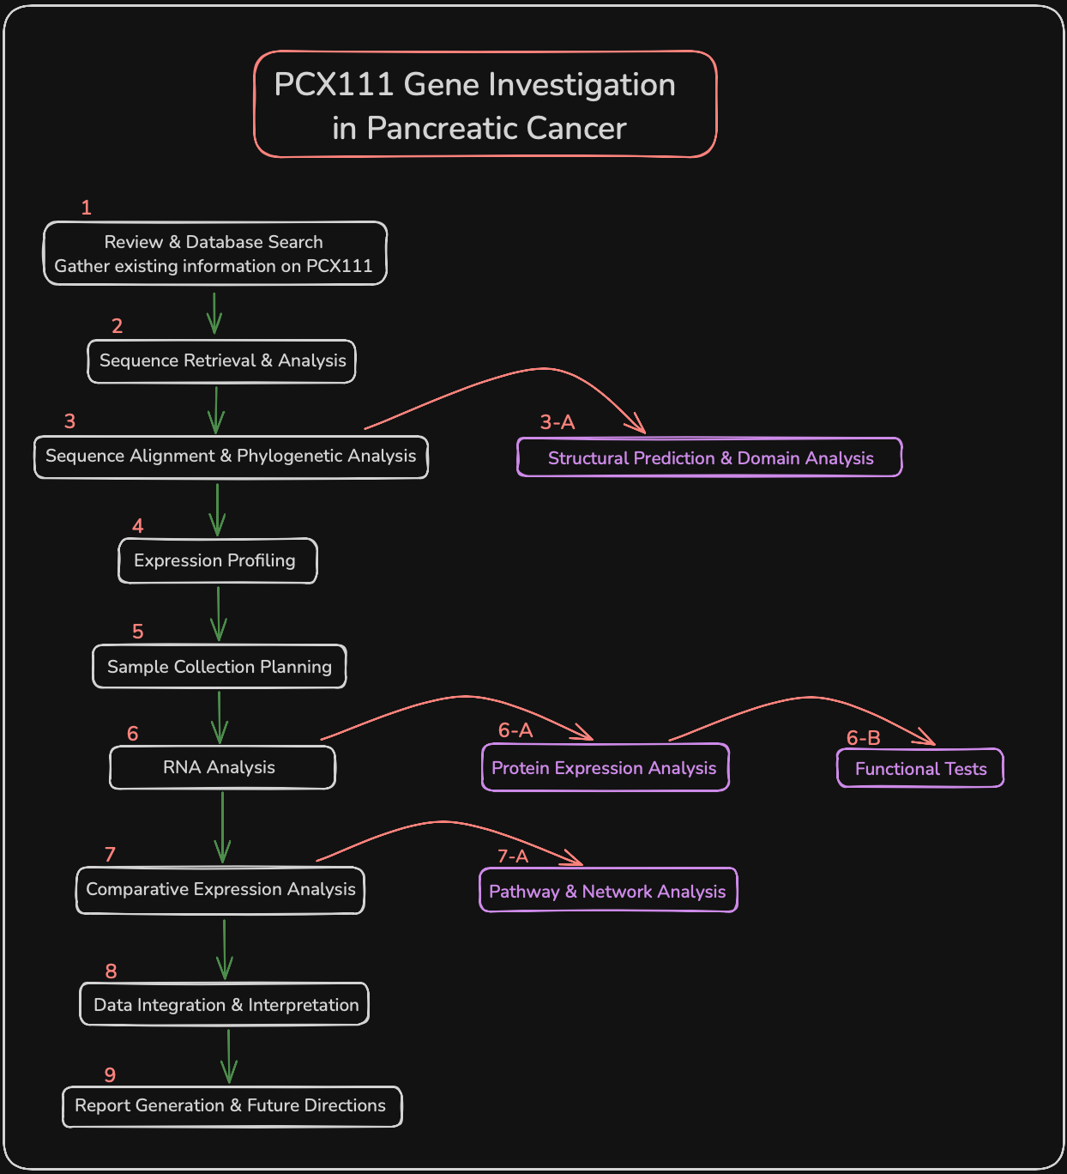
Step 1: Literature Review & Database Search

Objective: Gather all available information about PCX111 gene and its role in pancreatic cancer.
Databases/Tools:
- PubMed/MEDLINE: Scientific literature search
- Google Scholar: Additional academic sources
- OMIM: Online Mendelian Inheritance in Man database
- CancerGenes: Cancer gene database
- COSMIC: Catalogue of Somatic Mutations in Cancer

Process: Since PCX111 is hypothetical, this step would involve creating a comprehensive background based on similar pancreatic cancer genes, understanding current knowledge gaps, and establishing research questions.

Key Questions to Address:
- How PCX111 works in HUMANS: What is known about PCX111's role in human pancreatic cancer pathogenesis?
- How PCX111 works in OTHER PRIMATES: Do other primates develop pancreatic cancer? Any PCX111-related studies?
- Comparative aspects: Why would humans be even more vulnerable to pancreatic cancer than other primates?

Step 2: Sequence Retrieval & Analysis

Objective: Extract PCX111 gene and protein sequences of all primate species.
Databases/Tools:
- NCBI GenBank: Nucleotide sequence database
- Ensembl Genome Browser: Comparisons and genome annotations
- UCSC Genome Browser: Genome data visualization
- UniProt: Information on protein sequences and functions
- RefSeq: Reference sequences

Process: Search PCX111 orthologs in the other primate species (humans, chimpanzees, bonobos, gorillas, orangutans, macaques, etc.). Download both nucleotide and amino acid sequences. Verify sequence quality and completeness.

Specific Focus:
- HUMAN PCX111: Full genomic sequence, all isoforms, regulatory areas.
- PRIMATE ORTHOLOGS: Chimpanzee, gorilla, macaque, etc.
- Quality Control: Focus on the completeness and the accuracy of non-human species

Step 3A: Sequence Alignment & Phylogenetic Analysis

Objective: Compare PCX111 sequences across primate species to understand evolutionary relationships and conservation patterns.
Databases/Tools:
- ClustalW/ClustalOmega: Multiple sequence alignment
- MUSCLE: Multiple sequence alignment
- MEGA-X: Phylogenetic analysis software
- IQ-TREE: Maximum likelihood phylogenetic analysis
- FigTree: Phylogenetic tree visualization
- ConSurf: Conservation analysis

Process: Perform multiple sequence alignments, calculate sequence identity/similarity percentages, construct phylogenetic trees, identify conserved and variable regions, and analyze selection pressure using dN/dS ratios.

Key Analyses:
- HUMAN-SPECIFIC CHANGES: Amino acid substitutions unique to humans
- CONSERVED REGIONS: What's preserved across all primates
- HUMAN-PRIMATE DIVERGENCE: When did critical changes occur in human lineage?
- FUNCTIONAL IMPACT: Which human-specific changes might affect protein function?

Step 3B: Structural Prediction & Domain Analysis

Objective: Predict protein structure and identify functional domains to understand potential mechanisms.
Databases/Tools:
- AlphaFold: Protein structure prediction
- ChimeraX/PyMOL: Protein structure visualization
- Pfam: Database of Protein Families
- InterPro: Protein domain and functional analysis
- SMART: Simple Modular Architecture Research Tool
- PROSITE: Protein domain and functional site database

Process: Predict 3D protein structures, identify conserved domains and motifs, analyze potential binding sites, compare structural differences between species, and predict functional implications of sequence variations.

Comparative Analysis:
- HUMAN PCX111 STRUCTURE: Unique structural features, binding sites, domains
- PRIMATE PCX111 STRUCTURES: Conserved vs variable structural elements
- FUNCTIONAL IMPLICATIONS: The possible impact of struction differences:
  - Protein-protein interactions
  - DNA binding capacity
  - Enzymatic activity
  - Cellular localization

Step 4: Expression Data Mining

Objective: Perform an analysis of available gene expression data to interpret PCX111 expression patterns in different tissues, developmental and disease states.
Databases/Tools:
- GTEx: Genotype-Tissue Expression database
- Human Protein Atlas: Tissue and cell-specific expression
- GEO (Gene Expression Omnibus): Expression datasets
- ArrayExpress: Functional genomics data
- TCGA: The Cancer Genome Atlas
- cBioPortal: Cancer genomics data portal
- R/Bioconductor: Statistical analysis packages

Process: Find existing PCX111 expression data in standard and cancerous tissues, compare expression at different primate species (where possible), find associated genes that are co-expressed and conduct pathway enrichment analysis.

Step 5: Sample Collection Strategy

Objective: Plan and coordinate sample collection from different primate species for experimental validation.
Considerations and Steps:
- Ethical Approval: Obtain necessary permits and ethical clearances
- Sample Types: Plan for tissue samples, cell lines, or blood samples
- Species Selection: Choose representative primate species based on phylogenetic diversity
- Sample Preservation: Plan for RNA preservation (RNAlater, liquid nitrogen)
- Quality Control: Establish protocols for sample quality assessment

Process: Since this involves hypothetical samples, we would need to collaborate with zoos, research institutions, or use existing biobanks. For human samples, coordinate with hospitals and cancer centers.

Step 6A: RNA Extraction & qPCR

Objective: Determine the levels of PCX111 mRNA expression compared to the levels of different primate species and the tissues.
Laboratory Steps:
- RNA Extraction: Use TRIzol or commercial kits (Qiagen RNeasy)
- Quality Assessment: Check RNA integrity using Agilent Bioanalyzer
- cDNA Synthesis: Reverse transcription using SuperScript or similar
- Primer Design: Design species-specific or universal primers
- qPCR Setup: Use SYBR Green or TaqMan probes
- Data Analysis: Make calculations by using relative expression of ΔΔCt method

Tools for Analysis:
- Primer-BLAST: Primer design and specificity checking
- qPCR analysis software: StepOne, QuantStudio, or similar
- Statistical software: R, GraphPad Prism, or SPSS

Step 6B: Protein Expression Analysis

Objective: Analyze PCX111 protein expression and localization across primate species.
Laboratory Steps:
- Protein Extraction: Use RIPA buffer or similar for total protein
- Protein Quantification: Bradford or BCA assay
- Western Blotting: SDS-PAGE followed by immunoblotting
- Antibody Validation: Test PCX111-specific antibodies across species
- Immunohistochemistry: Tissue localization studies
- Immunofluorescence: Cellular localization in cultured cells

Resources for Antibodies:
- Antibody databases: CiteAb, Antibodypedia
- Commercial suppliers: Abcam, Cell Signaling, Santa Cruz
- Custom antibody services: If species-specific antibodies needed

Step 6C: Functional Tests

Objective: Assess PCX111 functional differences between primate species using cellular assays.
Laboratory Steps:
- Cell Culture: Maintain primate cell lines or primary cultures
- Transfection: Overexpress or knockdown PCX111 using plasmids or siRNA
- Cell Viability Assays: MTT, WST-1, or alamarBlue assays
- Migration Assays: Wound healing or Transwell migration
- Invasion Assays: Matrigel invasion chambers
- Apoptosis Assays: Annexin V/PI staining, caspase activity
- Cell Cycle Analysis: PI staining and flow cytometry

Cell Line Resources:
- ATCC: Cell line repository
- DSMZ: German cell culture collection
- Primate cell line databases: Species-specific repositories

Step 7A: Comparative Expression Analysis
Objective: Perform statistical analysis to compare PCX111 expression patterns between primate species.
Statistical Tools:
- R/Bioconductor: DESeq2, edgeR for differential expression
- Python: pandas, scipy, scikit-learn for data analysis
- GraphPad Prism: Statistical analysis and visualization
- SPSS: Advanced statistical analyses
Process: Run ANOVA or t-tests to compare levels of expression, control multiple testing, make heat maps and clustering analyses and discover patterns of species-specific expression.

Step 7B: Pathway & Network Analysis

Objective: Identify biological pathways and protein interactions associated with PCX111 across primate species.
Databases/Tools:
- STRING: Protein-protein interaction networks
- KEGG: Pathway database
- Reactome: Pathway database
- Gene Ontology: Functional annotation
- DAVID/PANTHER: Functional enrichment analysis
- Cytoscape: Network visualization and analysis
- IPA (Ingenuity Pathway Analysis): Commercial pathway analysis

Process: Select PCX111 interaction partners, conduct pathway enrichment analysis, compare the involvement of pathways between species and make their visualizations as networks.

Step 8: Data Integration & Interpretation

Objective: Integrate all experimental and bioinformatics results to come up with a comprehensive understanding of PCX111 in different primates.
Process: Concentrate sequence analysis, expression data, functional assay and pathway information. Determine the species-specific variation and their possible effect on pancreatic cancer sensitivity or growth. Formulate evolutionary adaptations hypotheses, and their functional outcomes.

Step 9: Report Generation & Future Directions

Objective: The summary of findings and research.
Process: Allocate follow up reports that entail methodology and findings, and interpretation of research results. Determine knowledge gap areas and be able to conduct follow up experimentation like functional validation in animal model, in depth mechanistic studies or target of therapy validation.

Publication and Sharing:
- Manuscript preparation: Peer reviewed journals
- Data sharing: Include sequences and expression in the open databases
- Presentations: Share findings with scientific community

